VA Medical Care Collections Fund (MCCF)   
Electronic Data Interchange (EDI)   
Transaction Applications Suite (TAS)

Version 2.0

Production Operations Manual



May 2019

**Department of Veterans Affairs**

**Office of Information and Technology (OI&T)**

Revision History

| Date | Version | Description | Author |
| --- | --- | --- | --- |
| May 15, 2019 | 2.0.1 | Minor updates & polishing | D McAllister |
| May 7, 2019 | 2.0 | Updated the Back-Up Procedures, Concurrency, Restart after Database Restore and Rollback Procedures sections. | C. Sesti (LC review 5/8) |
| January 29, 2019 | 1.3 | Corrected projects titles, and updated the logical and physical diagram. Made changes appropriate for Build 7. (lc reviewed 01302018) | M. Dawson |
| December 4, 2018 | 1.2 | Corrected document title & version number; removed template table, but noted template version used in Revision History. | T. Nichols |
| November 15, 2018 | 1.1 | Added MCCF EDI TAS Portal Start-up instructions to System Startup section. | Halfaker System Administration Team |
| July 22, 2018 | 1.0 | Initial version based on Template 1.6 dated March 2016. | MCCF EDI TAS |

Note: The revision history cycle begins once changes or enhancements are requested after the Production Operations Manual has been baselined.

Artifact Rationale

The Production Operations Manual provides the information needed by the production operations team to maintain and troubleshoot the product. The Production Operations Manual must be provided prior to release of the product.

Table of Contents

1. Introduction 1

2. Routine Operations 1

2.1. Administrative Procedures 1

2.1.1. System Start-up 1

2.1.1.1. System Start-Up from Emergency Shut-Down 1

2.1.2. MCCF EDI TAS Portal Start-up 1

2.1.3. New Version Deployment 1

2.1.4. System Shut-down 4

2.1.4.1. Emergency System Shut-down 4

2.1.5. Back-up & Restore 4

2.1.5.1. Back-Up Procedures 4

2.1.5.2. Restore Procedures 5

2.1.5.3. Back-Up Testing 5

2.1.5.4. Storage and Rotation 6

2.2. Security / Identity Management 6

2.2.1. Identity Management 6

2.2.2. Access control 6

2.3. User Notifications 6

2.3.1. User Notification Points of Contact 6

2.4. System Monitoring, Reporting & Tools 6

2.4.1. Dataflow Diagram 7

2.4.2. Availability Monitoring 7

2.4.3. Performance/Capacity Monitoring 7

2.4.4. Critical Metrics 8

2.5. Routine Updates, Extracts and Purges 8

2.6. Scheduled Maintenance 8

2.7. Capacity Planning 8

2.7.1. Initial Capacity Plan 8

3. Exception Handling 9

3.1. Routine Errors 9

3.1.1. Security Errors 9

3.1.2. Time-outs 9

3.1.3. Concurrency 9

3.2. Significant Errors 9

3.2.1. Application Error Logs 10

3.2.2. Application Error Codes and Descriptions 10

3.2.3. Infrastructure Errors 10

3.2.3.1. Database 10

3.2.3.2. Web Server 10

3.2.3.3. Application Server 10

3.2.3.4. Network 10

3.2.3.5. Authentication & Authorization 10

3.2.3.6. Logical and Physical Descriptions 11

3.3. Dependent System(s) 11

3.4. Troubleshooting 11

3.5. System Recovery 12

3.5.1. Restart after Non-Scheduled System Interruption 12

3.5.2. Restart after Database Restore 12

3.5.3. Back-out Procedures 13

3.5.4. Rollback Procedures 13

4. Operations and Maintenance Responsibilities 13

4. Approval Signatures 15

# Introduction

This document describes how to maintain the components of Medical Care Collections Fund (MCCF) Electronic Data Interchange (EDI) Transaction Applications Suite (TAS) in the Microsoft Azure Government (MAG)cloud environment of VAEC, as well as how to troubleshoot problems that might occur with this product while in production. The intended audiences for this document are the IT teams responsible for hosting and maintaining the system after production release. This document is normally finalized prior to production release, and it includes many updated elements specific to the hosting environment.

# Routine Operations

The MCCF EDI TAS product is deployed in the VAEC MAG environment, an IaaS environment that provides all routine support of hardware and connectivity operations. The MCCF product software is managed via the Jenkins automated deployment tool on the MCCF FPC server.

## Administrative Procedures

### System Start-up

All of the components of the MCCF EDI TAS System are implemented as services that start when the host server boots. Individual components (servers) can be (re)started within the MAG Administrative portal using the product owner’s Azure Portal account, or via the Jenkins application.

#### System Start-Up from Emergency Shut-Down

The VAEC MAG environment is an IaaS service provided by Microsoft. Emergency procedures are provided in the IaaS agreement.

### MCCF EDI TAS Portal Start-up

### New Version Deployment

To start-up the MCCF EDI TAS Portal application, run the “deploy_RTC_MCCF_TAS_Core” job in the Jenkins application to deploy the TAS Core application to the appropriate servers by clicking on the Name link.

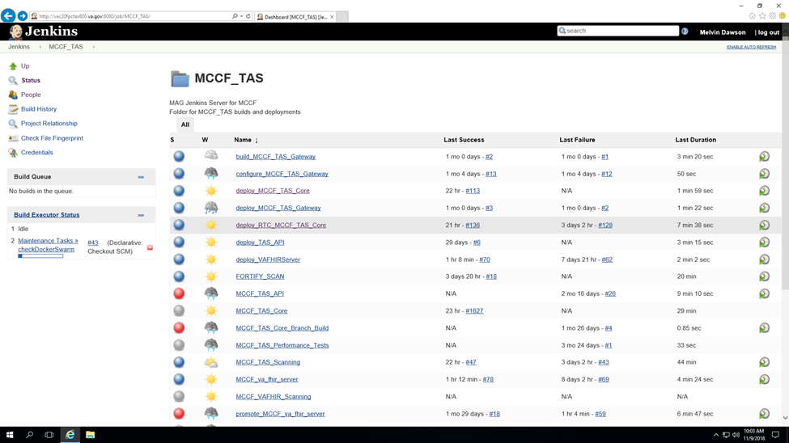

Next, you will be brought to the “Pipeline deploy_RTC_MCCF_TAS_Core” page. If not requesting the latest build, you can also specify the deployment_filename (e.g., mccf-tas_TAS.01.00.247_20180604_092635.tar.gz), which represents the file containing code for a specific build (e.g., Build 3, Build 5).

Select the target environment (ENV field) to deploy code.

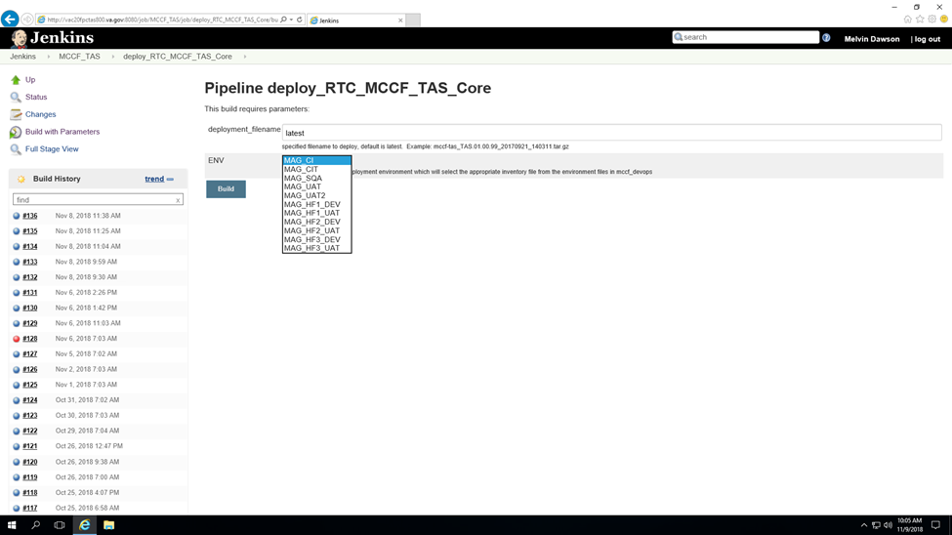

Once all fields are appropriately populated, the build process is started by clicking the Build button. Click on the orb at the top of the list on the left to open the Console Output page that will list the status of the deployment process. Continue to monitor until you receive a successful termination of the task.

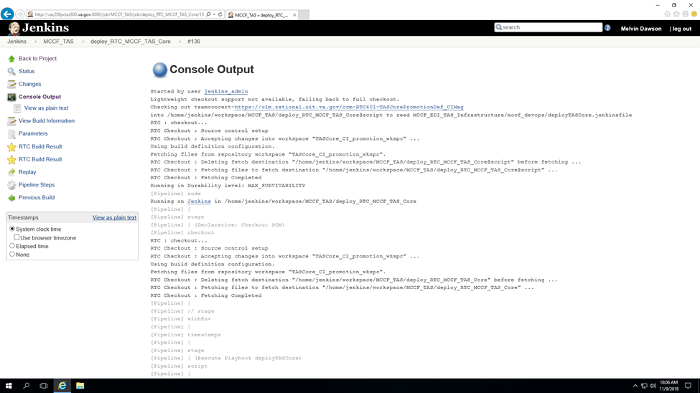

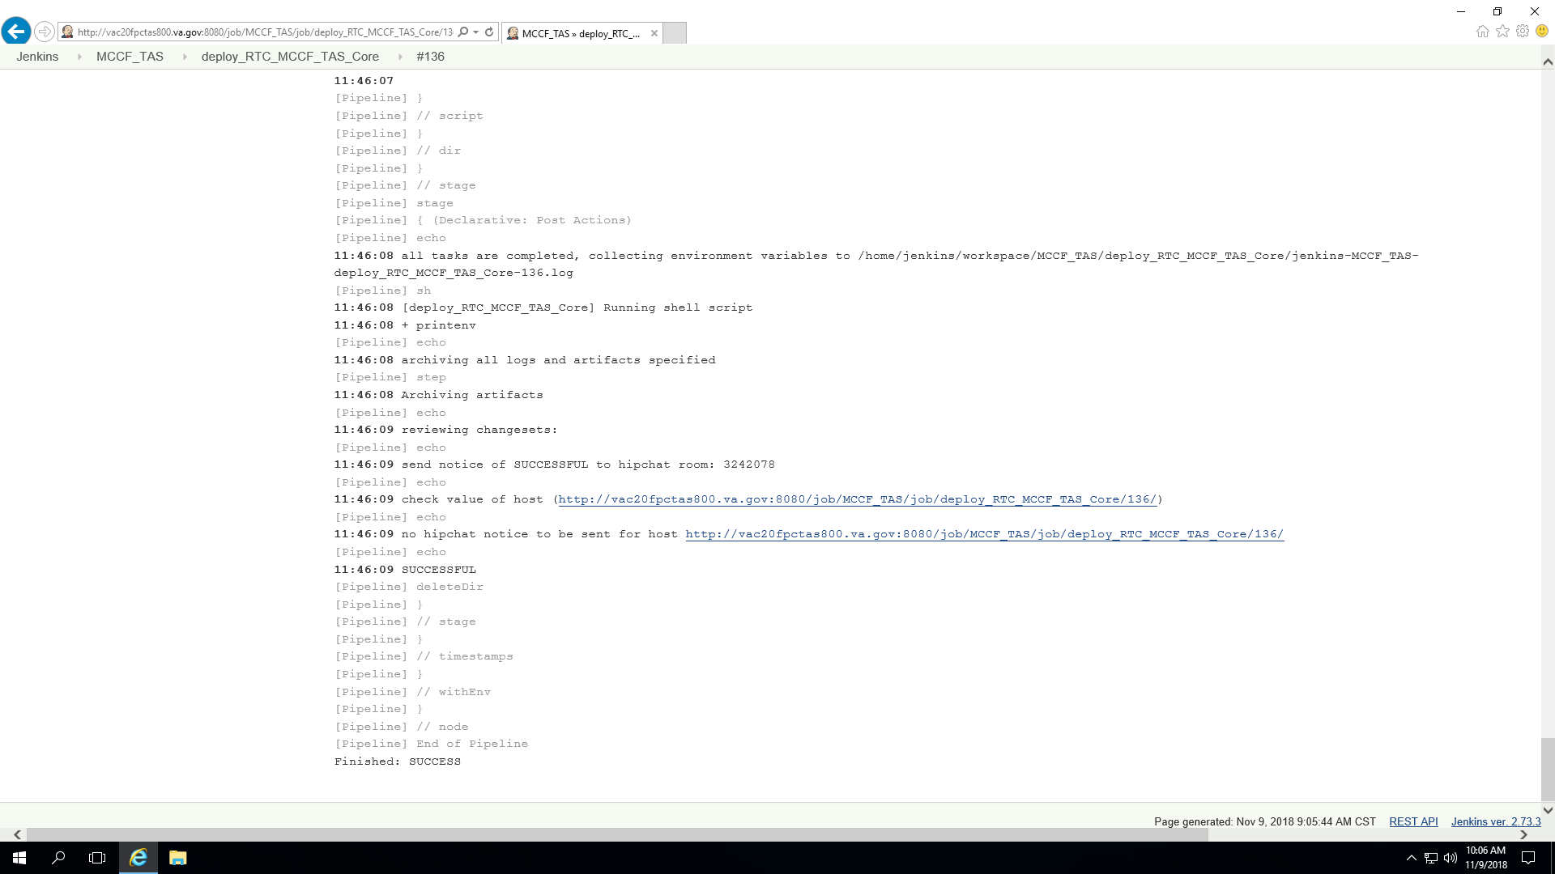

The MCCF EDI TAS application will automatically be available upon deployment. The components are implemented as services, and thus do not require manual intervention to initiate.

Once you have successfully deployed MCCF EDI TAS application (to all severs), verify that it is up and operational. To do so, go to the webserver's homepage from a web browser using this format:

**https://erevenue.va.gov**

Here is a screenshot of the TAS Portal homepage once it has been successfully started or restarted:

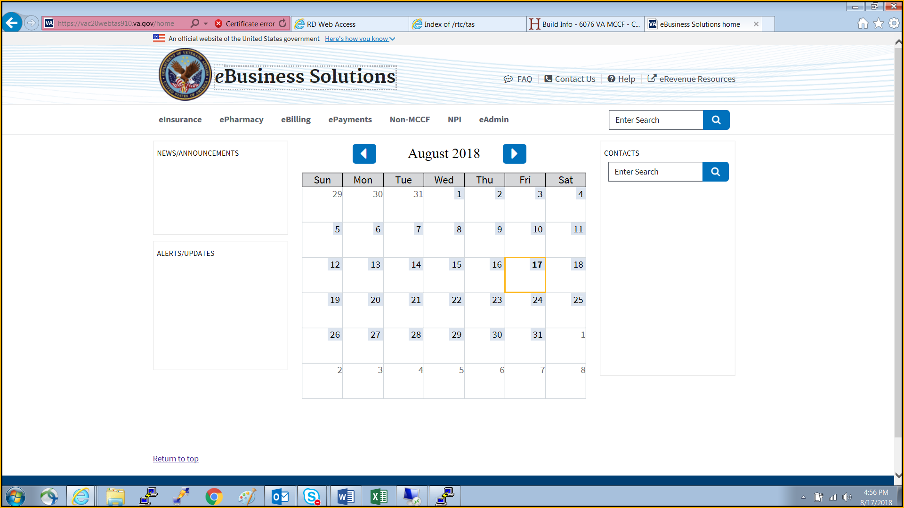

### System Shut-down

The VAEC MAG environment is an IaaS service provided by Microsoft. Physical system shut-down procedures are provided in the IaaS agreement.

Additionally, the product owner’s Administration personnel can initiate a MAG-specific shutdown using the Jenkins interface, or utilizing the Azure Portal.

#### Emergency System Shut-down

The VAEC MAG environment is an IaaS service provided by Microsoft. Emergency procedures are provided in the IaaS agreement.

Aditionally, the product owner’s Administration personnel can initiate a MAG-specific shutdown using the Jenkins interface, or utilizing the Azure Portal.

### Back-up & Restore

The MCCF stores all data – including PII – in CosmosDB, a VAEC MAG SaaS offering from Microsoft. All data not stored in CosmosDB is considered volatile and/or transactional and is not necessary to be backed up or restored.

CosmosDB backup and restore operations are described in the Microsoft Azure support document at the link below:

<https://docs.microsoft.com/en-us/azure/cosmos-db/online-backup-and-restore>

#### Back-Up Procedures

**Backup Schedule**

As noted above, only the CosmosDB stored data is backed up. As CosmosDB is provided as SaaS, the backup schedule shall be governed by the VAEC and Microsoft IaaS agreement.

The following image (from Microsoft documentation) illustrates periodic full backups of all Cosmos DB entities in GRS Azure Storage.

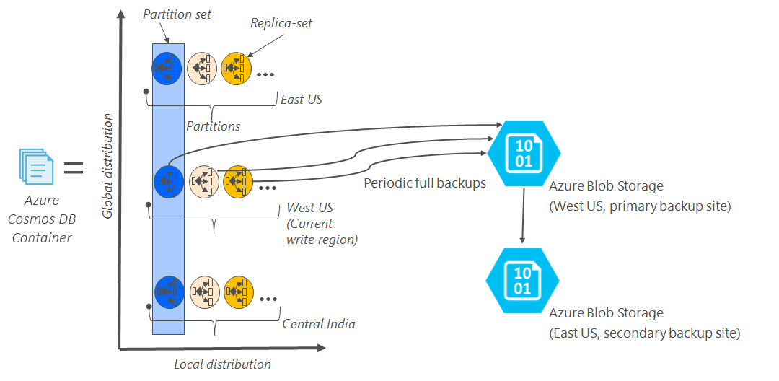

Figure 1 - Backup Procedures

**Backup retention period**

As described above, Azure Cosmos DB takes snapshots of data every four hours at the partition level. At any given time, the last two snapshots are retained. However, if the collection/database is deleted, the existing snapshots are retained for all deleted partitions within the given collection/database for 30 days.

_________________________________________________________________-

**Restoring a database from an online backup**

If a database or collection is accidentally deleted, the appropriate actions are to file a support ticket or to call Azure support to restore the data from the last automatic backup. Azure support is availability is determined by the VAEC / Microsoft IaaS agreement.

#### Restore Procedures

The following link provides CosmosDB backup and restore operations

<https://docs.microsoft.com/en-us/azure/cosmos-db/online-backup-and-restore>

In circumstances where a server environment becomes corrupted, it is faster and more efficient to re-image the system vs. attempting a repair/restoration. This is performed via the Jenkins application interface.

#### Back-Up Testing

Backups are retained by Microsoft, and testing of their fitness for use is part of the IaaS agreement with VAEC.

#### Storage and Rotation

As noted above, all data stored on MCCF EDI TAS servers is either in the CosmosDB, or is considered volatile data. CosmosDB data storage details are covered by the Microsoft / VAEC IaaS agreement.

## Security / Identity Management

The MCCF product subscribes to VA’s IAM service to enable users to gain role-based limited access to the system using VA PIV credentials.

System-level (privileged) access to the systems is restricted to System Administrators, and utilizes the VA Centrify service to gain control access using VA PIV credentials.

<https://vaww.strongauth.va.gov/RDWeb/Pages/en-Us/Default.aspx?reason=freeslots>

### Identity Management

All users and administrators gain access to MCCF systems using VA PIV credentials. Identity management is handled by the VA and its Active Directory (AD) infrastructure.

### Access control

Users and administrators can gain access to the MCCF systems only by using VA PIV credentials, either via the IAM or via Centrify services provided by the VA.

## User Notifications

All relevant users are notified via email of upcoming system changes and outages within an acceptable and reasonable time prior to the scheduled event(s). An email distribution list created by the product owner is used to send these notifications to the appropriate contacts.

### User Notification Points of Contact

Notifications will be sent to the personnel identified by the product owner. As noted in 2.3, an email distribution list created by the product owner is used to send these notifications to the appropriate contacts.

## System Monitoring, Reporting & Tools

Performance and other system monitoring services are provided by the Cloud Provider.

[https://docs.microsoft.com/en-us/azure/monitoring-and-diagnostics/monitoring-overview](https://docs.microsoft.com/en-us/azure/monitoring-and-diagnostics/monitoring-overview%20)

### Dataflow Diagram

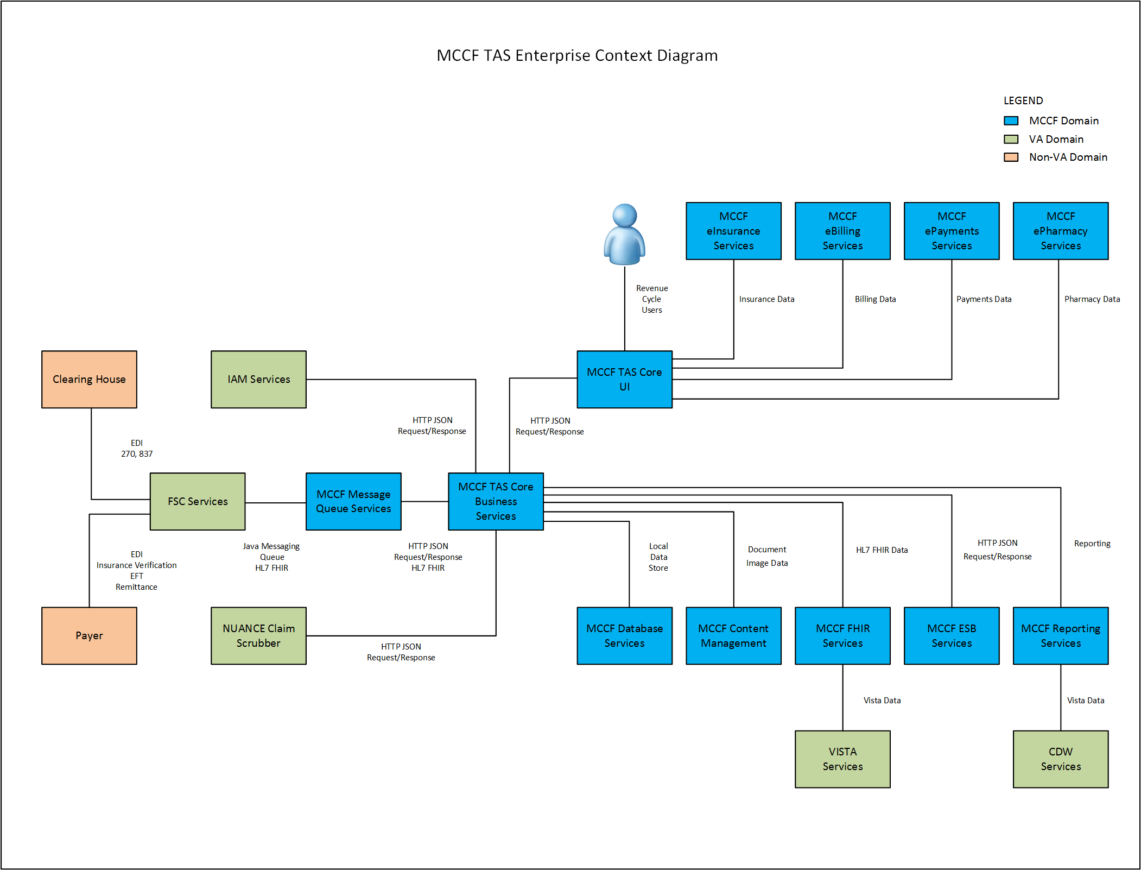

Figure 2 - Dataflow Diagram

### Availability Monitoring

Availability monitoring is performed within Azure. Please refer to the Microsoft Azure link below for more information:

[https://docs.microsoft.com/en-us/azure/monitoring-and-diagnostics/monitoring-overview](https://docs.microsoft.com/en-us/azure/monitoring-and-diagnostics/monitoring-overview%20)

### Performance/Capacity Monitoring

Performance/Capacity Monitoring of our systems can be performed locally, via the Azure Cloud Management Portal and can be scaled up relatively easily. As noted above, please refer to the Microsoft Azure link below for more information:

[https://docs.microsoft.com/en-us/azure/monitoring-and-diagnostics/monitoring-overview](https://docs.microsoft.com/en-us/azure/monitoring-and-diagnostics/monitoring-overview%20)

### Critical Metrics

CPU utilization, RAM utilization, network saturation, and blob storage usage within the Azure Cloud is routinely monitored using Azure tools as part of the IaaS agreement.

## Routine Updates, Extracts and Purges

All servers built and deployed in the MCCF EDI TAS environment in VAEC MAG are built from a VA provided system image / template. These instances are then patched with OS and software vendor patches utilizing the VA Infrastructure Operations (VA-IO) provided RedHat Satellite and Microsoft SCCM distribution methods. Although VA-IO makes monthly patches available for the Dev/Test and Pre-Production environments, the same patches are provided only *quarterly* for VA Production environments. Patches applied to the Pre-Prododuction environment are intended to serve as a validation platform for subsequent availability in Production.

The MCCF EDI TAS project is considered a “self-service” project, and so application of the monthly (or quarterly) OS patches is the responsibility of the development team (for DevTest environments) and the system administration staff of the product owners (for Pre-Production and Produection environments). See the project RACI document for details.

## Scheduled Maintenance

The MCCF EDI TAS product has been developed, and is operationally maintained, using an Agile Continuous Integration / Continuous Deployment (CI/CD) methodology. As a result, there is no set schedule of software maintenance. Hardware maintenance schedules would fall under the IaaS agreement.

## Capacity Planning

Required analysis is completed to identify and define the achievable QoS levels for applicable capacity and performance metrics, and to determine how these will be monitored and enforced; QoS levels to be delivered will be those that are either at least equal to corresponding industry benchmarks or those that reflect situational specifics of the information technology in question. **Applies to MCCF once the MCCF Detailed Application Design and performance requirements are finalized.**

Capacity measures include those from the processing, utilization, and concurrency rates for system components.

### Initial Capacity Plan

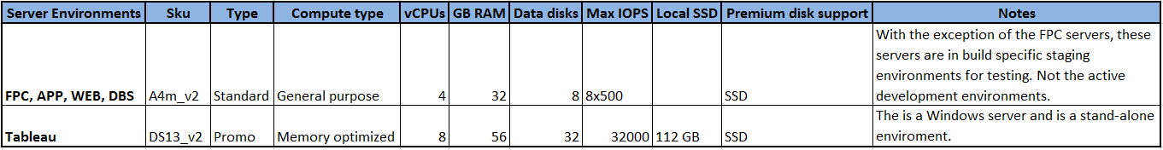

Figure 3 - Server Environment within Azure

# Exception Handling

The MCCF product is primarily a web-based product, and errors and defects can be detected by the system, or reported by end-users. In both instances, remediation can be completed quickly and efficiently through the Agile delivery process.

## Routine Errors

The MCCF product will report runtime errors and other detected system anomalies via email to a pre-defined (product owner defined) group. Because MCCF is designed using the Agile methodology, defects can be identified and mitigated quickly by the appropriate development and/or operational teams.

### Security Errors

The MCCF product will report runtime errors and other detected system anomalies via email to a pre-defined (product owner defined) group. Because MCCF is designed using the Agile methodology, defects can be identified and mitigated quickly by the appropriate development and/or operational teams. Certain security violations may originate from the VA Active Directory components, such as Centrify or IAM.

### Time-outs

Time-out and other connection-related security functions are managed and controlled by the VA-provided credentialing (IAM SSOi) as noted above.

### Concurrency

Concurrency in VA systems is managed and controlled by VA-provided credentialing: IAM SSOi. Beginning with Build 10, the MCCF EDI TAS web servers will be load balanced between a range of identical web server systems using cloud-provider load balancing services.

## Significant Errors

The MCCF product is primarily deployed in the MAG environment. As a result, most hardware and connection-level errors will be managed per the VA / Microsoft IaaS agreement. Software issues will usually generate error messages that the system operators may consult using the Jenkins tool to determine their root-causes.

### Application Error Logs

The MCCF product is primarily a web-based application. The system logs for the webserver, and other supporting applications are in Linux-standard locations (/var/log) which are visible to the Jenkins administrator.

### Application Error Codes and Descriptions

The MCCF product does not generate product-specific error codes.

### Infrastructure Errors

Infrastructure error remediation will be controlled and managed by the VA / Microsoft IaaS agreement.

#### Database

The MCCF product uses the Microsoft CosmosDB database in the VAEC MAG environment as an SaaS product. As such, all database errors will be managed and remediated per the Microsoft / VA IaaS agreement.

#### Web Server

The MCCF product is primarily a web-based application. The system logs for the webserver and other supporting applications are in Linux-standard locations (/var/log) which are visible to the Jenkins administrator.

#### Application Server

The MCCF Application Servers provide HAPIFHIR services to the MCCF web application. Log files for this server are located on the responsible application server, and are in the Linux-standard locations (/var/log) which are visible to the Jenkins administrator.

#### Network

The network is administered by Microsoft Azure and the maintenance of the VA MAG network is therefore divided between VAEC and Microsoft. See the project RACI document for details of individual responsibilities.

#### Authentication & Authorization

The MCCG product authenticates users with VA-provided mechanisms (IAM and Centrify), each of which provides its own authentication and authorization logging.

#### Logical and Physical Descriptions

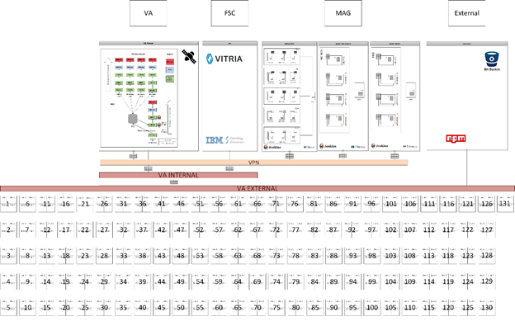

Figure 4 - MCCF Physical Architecture

## Dependent System(s)

MCCF EDI TAS is dependent on the VA Rational Team Concert (RTC), from which the applications pull software components to assemble, compile and deploy.

MCCF EDI TAS is dependent on the VA Identity Access Management (IAM) service, which is used to validate end-users via Personal Identity Verification (PIV) cards.

MCCF EDI TAS is dependent on the VA Active Directory infrastructure through the use of Centrify for user (administrator) controlled access.

MCCF EDI TAS is dependent on the CosmosDB in the VAEC MAG environment.

## Troubleshooting

To facilitate problem investigation, a central account is planned for receiving key VM messages. Messages from the AIDE (Advanced Intrusion Detection Environment) file will be routed to [MCCFOerationsSupportTeam@va.gov](mailto:MCCFOerationsSupportTeam@va.gov). Messages from the Linux utility Logwatch repository may later be added to central routing. Central routing of key messages does not preclude the possible need to research all VM log files.

## System Recovery

As noted above, the MCCF server components are deployed to virtual machines in the VAEC MAG environment. The MAG environment is not well-suited for recovering failed Linux systems. Additionally, experience has demonstrated that re-building and re-deploying a VM in MAG is significantly faster and more reliable than attempting to recover a faulted system.

### Restart after Non-Scheduled System Interruption

Systems might restart because of issues within the VM itself or due to an application anomaly. The workload or role that's running on the VM might trigger a bug check within the guest operating system. To determine the reason for the crash, view the system and serial logs for Linux VMs. Once the issue has been found and resolved, the Linux VM can be restarted via the Azure Cloud Portal Dashboard using an automated script. Below is an example:

To restart a VM using the Azure portal, select your VM and click the **Restart** button as in the following example:

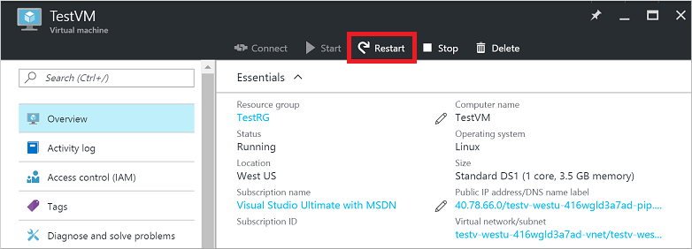

Figure 5 - Azure Portal

There are few cases where our VMs are rebooted due to planned maintenance to the underlying infrastructure. The following represents cases that are impactful to the availability of VMs hosted in Azure:

* Notification sent at least 30 days before the impact.
* Visibility to the maintenance windows per each VM.
* Flexibility and control in setting the exact time for maintenance to impact your VMs.

The **Pre-emptive Maintenance Window** provides the flexibility to initiate the maintenance on our VMs. By doing so, one can determine when VMs are impacted, the sequence of the update, and the time between each VM being maintained.

### Restart after Database Restore

The MCCF EDI TAS project uses the CosmosDB in the VAEC MAG environment on a transactional basis. The MCCF EDI TAS product should not have to be re-started in the event of a database restore operation. Should a restart be desired, it can be performed either through the Jenkins management tool, or via the Azure portal.

### Back-out Procedures

There are no back-out procedures. If a system is running an undesired MCCF product revision, it can be either rebuilt or redeployed from the Jenkins console.

### Rollback Procedures

The MAG Cosmos Database is provided by the MAG Cloud Provider as a SaaS product. Rollback Procedures are provided by the cloud provider.

# 4. Operations and Maintenance Responsibilities

The following table contains a description of the operations and maintenance roles and responsibilities.

| **Role & Brief Description** | **Assigned Organization**  **(Pillar and Sub-office)** | **Contact Information** |
| --- | --- | --- |
| Tier 0: Local End User Support (e.g. Automated Data Processing Application Coordinator (ADPACS)) | N/A – This is not a desktop application. Browser configuration requirements will be published and URL. We do not provide local end user support. | N/A |
| Enterprise Service Desk Tier 1: Provide first contact resolution via Knowledge Documents retained in Service Now.  NOTE: The MCCF EDI TAS PjM is coordinating with the ESD to integrate TAS support. | ITOPs (Enterprise Service Desk) | 855-NSD-HELP (855-673-4357) |
| Tier 2: The second level of service provider functions, which include problem screening, definition, and resolution. Service requests that cannot be resolved at this level in specific timeframe are elevated to appropriate service providers at the Tier 3 level. | Releases to date – TAS project team is supporting.  FSC is currently determining level and type of support. | ESD Tickets escalated to Tier 2  For initial release, ESD will not be integrated into support.  POC: Toby Rudik or Jim Plastow |
| Tier 3: The third level of service provider functions, which consist primarily of problem identification, diagnosis, and resolution. Service requests that cannot be resolved at the Tier 2 level are typically referred to the Tier 3 for resolution. | Releases to date – TAS project team is supporting.  FSC is currently determining level and type of support. | ESD Tickets escalated to Tier 3  For initial release, ESD will not be integrated into support.  POC: Toby Rudik or Jim Plastow |
| Receiving Org/Sustainment Manager: Coordinates ongoing support activities including budget reporting, contract management, and technical risk management during O&M.  ** If applicable, include key details such as whether this individual will be reviewing deliverables from an O&M contract. | Releases to date – FSC team is executing as Receiving Organization. | POC: Jimmy Medrano |
| COR ** Check with the Contracting Officer to determine if a certified COR is required and at what level during O&M. | EPMO | POC: Toby Rudik or Jim Plastow |
| Contracting Office | Technical Acquisition Center (TAC) | POC: TBD |

**RACI Matrix**



# Approval Signatures

REVIEW DATE: <date>

SCRIBE: <name>

________________________________

Katrina Tuisamatatele or Designee

Health Portfolio Director

________________________________

Frank Annecchini

Product Owner

________________________________

Jimmy Medrano

Receiving Organization POC

________________________________

Toby Rudik

Operations Support POC